REQUIREMENT ANALYSIS

1. Data Flow Diagram (DFD) Components
Since a DFD is a visual map, here is the structured data to include in your diagram:
External Entities (Squares):
- ServiceNow Admin: Creates configurations and manages migration.
- Support Agent: Interacts with the Incident form.
- Target Instance (Production): Receives the migrated update set.
Processes (Circles/Ovals):
- Capture Configuration: UI Policy logic is recorded into the Local Update Set.
- Export/Import Data: XML file movement between environments.
- Evaluate UI Logic: System checks if State == In Progress.
- Enforce Mandatory Rule: System toggles the Priority field attribute.
Data Stores (Open Rectangles):
- sys_ui_policy Table: Stores the logic records.
- sys_update_xml Table: Stores the captured changes in the Update Set.
- Incident Table: Stores the operational ticket date

- 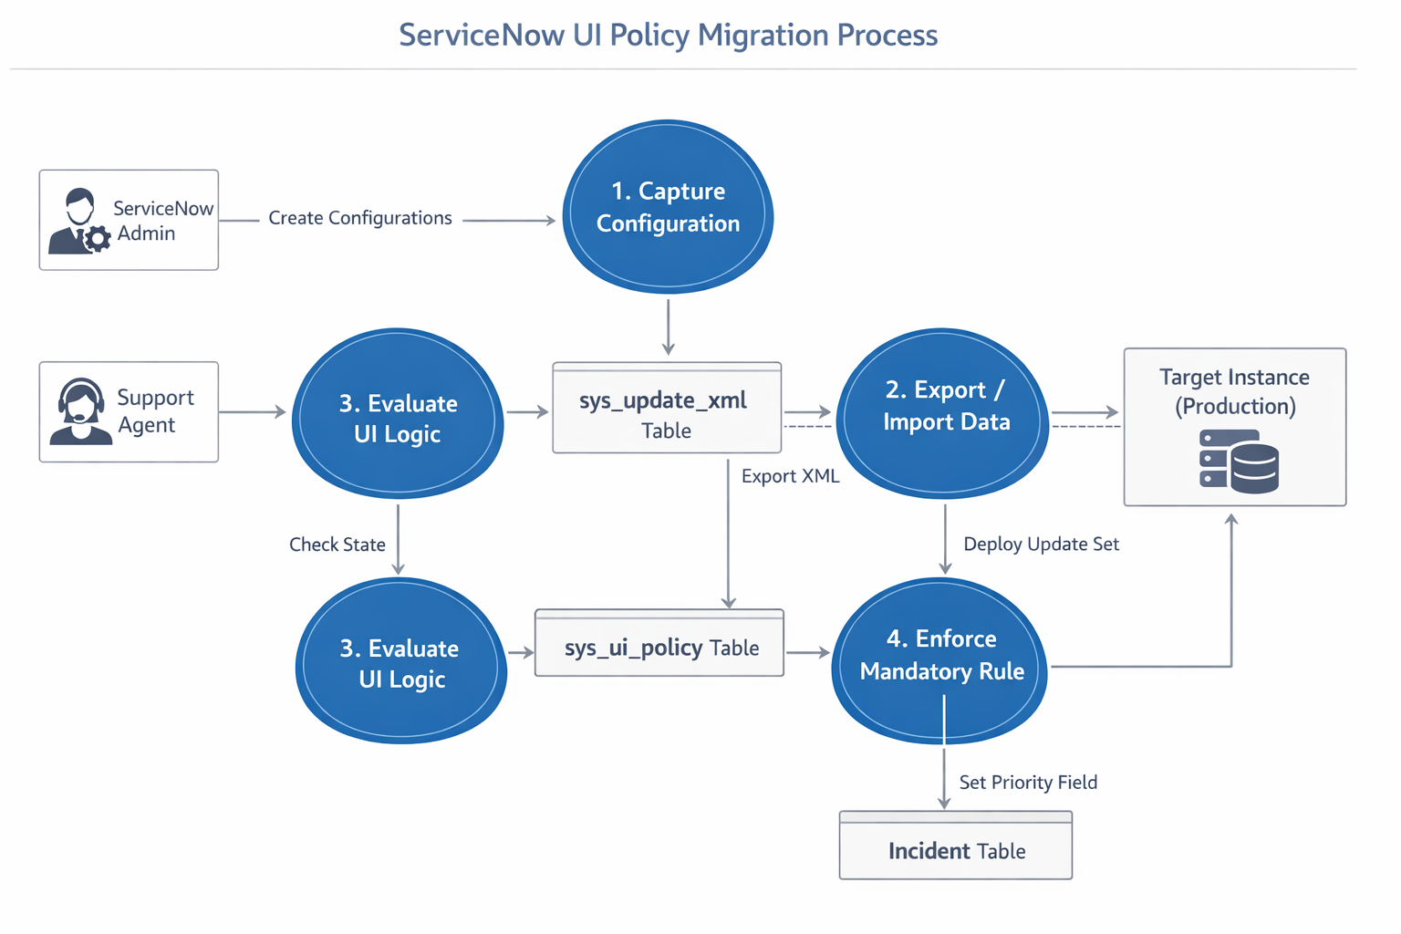
User Stories

ID | Role | User Story | Acceptance Criteria
US01 | Support Agent | As a Support Agent, I want the Priority field to automatically become mandatory when the Incident State is changed to "In Progress", so that every active incident has a defined priority level. | 1. When State = In Progress, the Priority field displays a red mandatory indicator. 2. The system prevents saving the record if Priority is empty. 3. A validation message prompts the user to fill the Priority field.
US02 | Support Agent | As a Support Agent, I want the Priority field to remain optional when the Incident State is "New", so that tickets can be logged quickly without full prioritization. | 1. When State = New, the Priority field is not mandatory. 2. The form allows saving even if Priority is blank.
US03 | ServiceNow Admin | As a ServiceNow Admin, I want all UI Policy and UI Policy Action configurations to be captured automatically in the active Update Set, so that configuration changes can be migrated safely between instances. | 1. Changes appear in the Customer Updates list. 2. Records are stored in the sys_update_xml table. 3. Update Set status is marked Complete before migration.
US04 | ServiceNow Admin | As a ServiceNow Admin, I want to export the Update Set as an XML file and import it into the Production instance, so that the same UI Policy behavior works in Production. | 1. Update Set exports successfully as XML. 2. XML imports into the Production instance without errors. 3. UI Policy works correctly after committing the Update Set.
US05 | IT Manager | As an IT Manager, I want to ensure that every incident in the "In Progress" state has a defined Priority, so that incident management reporting is accurate. | 1. Reports show 0 incidents with empty Priority when State = In Progress. 2. Dashboard confirms 100% priority compliance for active incidents.
US06 | Support Agent | As a Support Agent, I want the Priority field to visually highlight when the State changes to "In Progress", so that I immediately know the field must be filled. | 1. Priority field shows a red asterisk indicator. 2. Field is visually highlighted on the form. 3. Record cannot be saved until Priority is entered.
US07 | ServiceNow Admin | As a ServiceNow Admin, I want to test the UI Policy in the development instance before migration, so that errors are detected before deploying to Production. | 1. UI Policy triggers correctly when State = In Progress. 2. Priority field becomes mandatory during testing. 3. No errors appear in system logs.
US08 | IT Manager | As an IT Manager, I want to generate reports on incident priority usage, so that I can monitor incident management performance. | 1. Reports display incidents grouped by Priority level. 2. Reports show all In Progress incidents with assigned Priority values.

Solution Requirements
1. Functional Requirements (FR)
These requirements define the specific behaviors and logic the system must perform.
- FR1: Conditional Mandatory Logic: The system shall automatically set the "Priority" field to mandatory only when the "State" field of an Incident record is changed to "In Progress."
- FR2: UI Policy Execution: The mandatory requirement must be enforced on the client-side (browser) in real-time without requiring a page reload.
- FR3: Reversible Logic: The system shall automatically make the "Priority" field optional again if the "State" is changed back to "New" or moved to "On Hold."
- FR4: Form Validation: The system shall prevent a user from saving or updating an Incident record if the State is "In Progress" and the Priority field is empty.
- FR5: Configuration Capture: All changes to UI Policies and UI Policy Actions must be automatically captured within a designated "Current" Update Set.
2. Technical Requirements (TR)
These requirements define the platform-specific needs.
- TR1: Low-Code Implementation: The solution must utilize the ServiceNow UI Policy engine instead of Client Scripts to ensure better performance and easier maintainability.
- TR2: XML Portability: The configuration must be exportable as an XML file to facilitate manual movement between instances where a direct connection is not available.
- TR3: Update Set Integrity: The Update Set must include both the Parent UI Policy record and the Child UI Policy Action record to function correctly upon migration.
- TR4: Table Scope: The requirement applies specifically to the incident table within the Global application scope.
3. Migration Requirements (MR)
These requirements ensure the solution can be moved across the environment landscape.
- MR1: Conflict Resolution: The system must provide a "Preview" mechanism on the target instance to identify and resolve any collisions with existing local configurations before committing.
- MR2: Version Control: Each Update Set must have a unique, descriptive name and a "Completed" state before it can be exported.
- MR3: Deployment Consistency: The UI Policy logic must behave identically on the Target instance (Production) as it did on the Source instance (Development).
4. Non-Functional Requirements (NFR)
These requirements define the quality and constraints of the system.
- NFR1: Usability: The mandatory indicator (red asterisk) must be clearly visible to the user to provide immediate feedback on form requirements.
- NFR2: Performance: The UI Policy must trigger in less than 1 second after the State field is modified by the user.
- NFR3: Security: Configuration access must be restricted to users with the admin or ui_policy_admin roles to prevent unauthorized changes to business logic.
- NFR4: Reliability: The migration process must allow for a "Back Out" option if the committed changes cause unexpected issues in the production environment.
.

Technology Stack: ServiceNow Configuration & Migration
1. Core Platform
- Platform: ServiceNow (Vancouver / Washington DC Release)
- Environment: Multi-instance architecture (Development, Test, and Production)
- Application Scope: Global Scope (Standard ITSM environment)
2. Configuration Tools (Logic)
- UI Policy Engine: A client-side logic builder used to set field attributes (Mandatory, Visible, Read-Only) without scripting.
- UI Policy Actions: The specific instructions executed by the UI Policy to modify the Priority field on the Incident form.
- Condition Builder: The native ServiceNow tool used to define the trigger logic (State is In Progress).
3. Migration & DevOps Framework
- Update Sets: The primary container used to capture, group, and move customizations between instances.
- Update Set Picker: A developer tool used to ensure changes are recorded in the correct local set.
- XML (Extensible Markup Language): The data format used to export the Update Set for manual import into the target instance.
4. Functional Modules
- Incident Management: The core ITSM module where the "Mandatory Priority" rule is applied.
- User Administration: Used for defining the roles (Admin/ITIL) required to interact with or configure the system.
- System UI: The administrative module where UI Policies are stored and managed.
5. Development Methodology
- Low-Code/No-Code: Utilizing native platform configurations instead of custom JavaScript (Client Scripts) to ensure easier upgrades and better performance.
- Agile/Scrum: Following a structured "Capture
- $→$Test $→$Migrate $→$Commit" workflow.

Why this stack?
- Efficiency: UI Policies run faster in the browser than complex scripts.
- Safety: Update Sets allow for a "Preview" phase to catch errors before they hit Production.
- Maintainability: Native platform features are easier for future admins to understand and update.

